Machine Learning exercise 4

Eden Dupont 204808596

# Theoretical Part

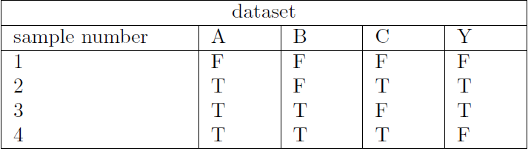

1.

**Question: Using the dataset above, we want to build a decision tree which classifies**

**Y as True (T) or False (F) given the binary variables A, B, C.**

**Draw the tree that would be learned by the greedy algorithm with zero training**

**error. You do need to show computations.**

Final solution (full solution below)

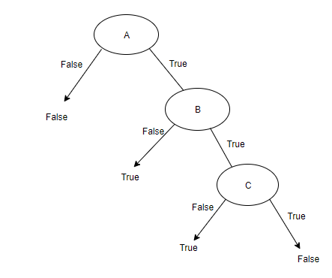

Full solution:

Using the greedy algorithm, I will choose the feature which has the least errors

In this case:

For A -

A(F)=F values expected, 0 errors

A(T)=T values expected, 1 errors (1 out of 3 False values)

Total error = 1

For B -

B(F)=F values expected, 1 errors (1 out of 2 True values)

B(T)=T values expected, 1 errors (1 out of 2 False values)

Total error = 2

For C -

C(F)=F values expected, 1 errors (1 out of 2 True values)

C(T)=T values expected, 1 errors (1 out of 2 False values)

Total error = 2

We will take the feature with the lowest error as the parent node for the next steps

Now, if:

A=False

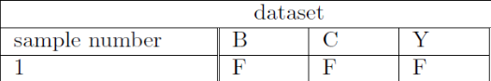

From here we cannot split the Y values anymore and therefore we create a leaf where A=False

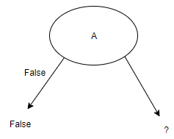

Next, for A=True

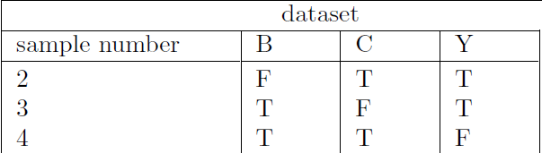

B(F)=T values, 0 error

B(T)=F values, 1 error

1 error total

C(F)=T values, 0 error

C(T)=F values, 1 error (1 of 2 is false)

1 error total

In this case, we will choose feature B arbitrarily

**New tables**

B=False

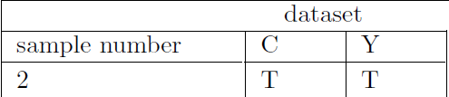

We cannot split the Y values and therefore we put a leaf of Y=T where B is False:

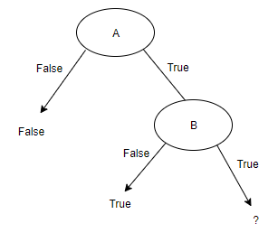

B=True

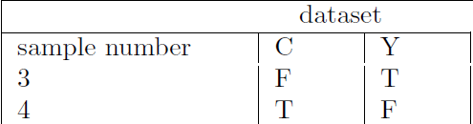

Here we can easily split C to two with zero error and the following tree is generated:



**2. Question: Is this tree optimal (i.e.,does it get zero training error with minimal**

**depth)? Explain in less than two sentences. If it is not optimal, draw**

**the optimal tree as well.**

**Solution:**

There is zero training error but the tree is not minimal, feature A can be discarded to create a tree with only B and C to correctly decide Y

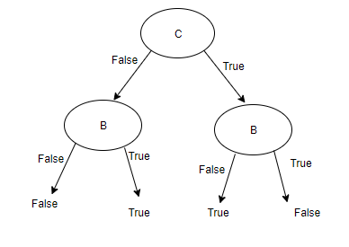

In this case, the tree is of smaller height

**3. Question: We will use the dataset below to learn a decision tree which predicts if**

**people pass machine learning (Yes or No), based on their previous GPA**

**(High, Medium, or Low) and whether or not they studied. On the following calculations use log on a base of 2.**

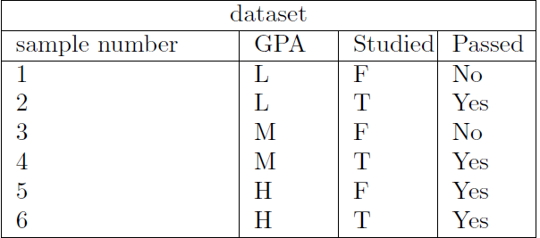

**4. What is the entropy of H(Passed)?**

P(Passed=True) = 4/6

P(Passed=False) = 2/6

H(Passed) = -[P(passed)*log(P(passed)) + P(not passed)*log(P(not passed))] = 0.27643

**5. What is the entropy of H(Passed | GPA)?**

**H(Passed | GPA=H) = $-\frac{2}{2}*log(\frac{2}{2})-\frac{0}{2}*log(\frac{0}{2})=0$**

**H(Passed | GPA=L) = $-\frac{1}{2}*log(\frac{1}{2})-\frac{1}{2}*log(\frac{1}{2})=1$**

**H(Passed | GPA=M) = $-\frac{1}{2}*log(\frac{1}{2})-\frac{1}{2}*log(\frac{1}{2})=1$**

**6. What is the entropy of H(Passed | Studied)?**

**H(Passed | Studied=True) = $-\frac{3}{3}*log(\frac{3}{3})-\frac{0}{3}*log(\frac{0}{3})=0$**

**H(Passed | Studied=False) = $-\frac{1}{3}*log(\frac{1}{3})-\frac{2}{3}*log(\frac{2}{3})=0.27643$**

**7. Draw the full decision tree, that would be learned for this dataset. You**

**do not need to show any calculations.**

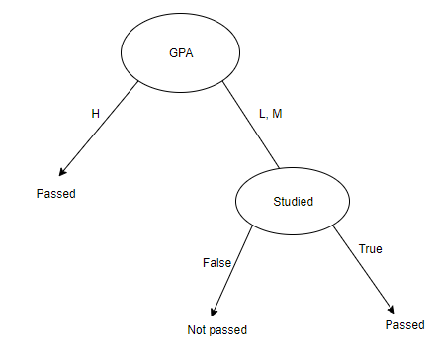

**8. Suggest three different improvements to the algorithm that could improve**

**the result (add your answer to the theoretical part).**

Answer:

1. Use weighted features, to force order change in the tree (bypassing the feature choice with the information gains)
2. Limit the model with max_depth, to force the tree to be shorter and search for a more optimal model